 | Title | Instructor | Description | Room
www.SignUpGenius.com/go/10C0A49AEA72BA13-artdocent
9:45 – 10:45
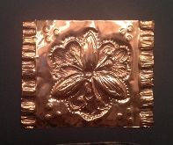 | Copper Embossing | Betty Gilstrap | Betty is an expert metal worker and loves teaching this deceptively simple art form. You an incorporate line, patterns, focal point and metal arts with a stunning product. | Multi-Purpose 610
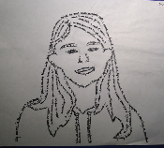 | Drawing With Words: Micrograph Self Portraits | Heather McClure-Coleman | Self Portraits created from writing tiny text that forms an image when viewed at a distance. Heather will walk you through this unique art form that merges writing and visual arts. A wonderful art integration lesson! | Library
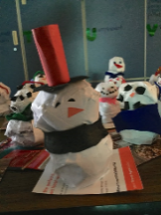 | Wintery Paper Mache’ | Linda Mori | Learn how to make a form of paper mache’ that can be completed within the classroom time constraints and take home a winter themed (Evergreen or Snowman) piece. | Activity 421
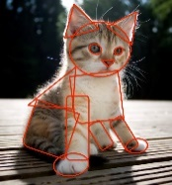 | Drawing: Seeing Geometric Shapes in Objects | Peggy Breautigam | You will learn a great process for learning to draw. You will get to practice this each approach and learn tips to take it back to your classroom. http://peggybraeutigam.com/ | Library
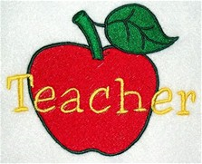 | Classroom management | Shannon Brannon | How to manage time, kids and your relationship with your teacher. | Chinook 427
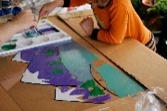 | Reverse painting on Plexiglas w/ enamel paints | Tanya Hansen | This project will have your kids thinking detail to background. Plexiglas sizes for readymade frames. | Coho 422
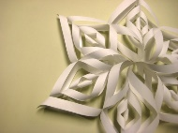 | Giant Snow Flakes | Tiffany Aske | Get ready for winter and get out your scissors. Let kids work big, teach space awareness and cutting skills. | Volunteer 210

11:00 – 12:00
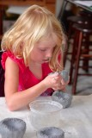 | Clay Play & The Basics of Clay Hand-building [Grades K-5] |  | Betsy Matias |  | Agility, coordination, strength, control, imagination, problem solving and sensory development – that’s CLAY CLASS! Knead, shape, cut, coil, roll, score, slip, wedge, experience awe, repeat. In this workshop you will learn how to confidently present a clay lesson to your students that emphasizes PROCESS over PRODUCT and help your students develop basic hand-building skills that will nurture their large & fine motor skills, self-expression and creative confidence. http://www.henryandmei.com/about/ | Activity 421
 | Copper Embossing |  | Betty Gilstrap |  | Betty is an expert metal worker and loves teaching this deceptively simple art form. You can incorporate line, patterns, focal point and metal arts with a stunning product. | Multi-Purpose 610
 | Drawing With Words: Micrograph Self Portraits |  | Heather McClure-Coleman |  | Self Portraits created from writing tiny text that forms an image when viewed at a distance. Heather will walk you through this unique art form that merges writing and visual arts. A wonderful art integration lesson! | Library
 | Printmaking |  | Leslie Stein Moon |  | Learn a fun and simple relief printing technique to teach your kids. They can create an original image and then experiment with printing it as a mono print. Leslie is a professional artist who makes fabulous, happy and fun prints sold in local galleries. https://lesliemoon.wordpress.com/about-my-process/ | Sockeye 322
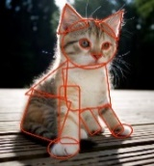 | Drawing: Seeing Geometric Shapes in Objects |  | Peggy Breautigam |  | You will learn a great process for learning to draw. You will get to practice this each approach and learn tips to take it back to your classroom. http://peggybraeutigam.com/ | Library
 | Watercolor |  | Shannon Brannon |  | Water color techniques for elementary kids | Chinook 427
 | Reverse painting on Plexiglas w/ enamel paints |  | Tanya Hansen |  | This project will have your kids thinking detail to background. Plexiglas sizes for ready-made frames. | Coho 422
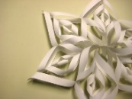 | Giant Snow Flakes |  | Tiffany Aske |  | Get ready for winter and get out your scissors. Let kids work big, teach space awareness and cutting skills. | Volunteer 210
12:15 – 1:15
Lunch time in Lunch room |  |  | If you purchased lunch, then please give your lunch ticket to attendant and enjoy the Chipotle buffet. If you brought your lunch then enjoy your time with other docents.
 | Online Docent Resources |  | Juliette Ripley-Dunkelberger |  | Introduction of the One Drive with lessons, arts advocacy, administrative tools and photos. | Lunch Room
1:15 – 2:15
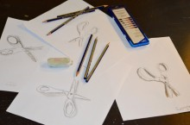 | Drawing on the Right Side of the Brain & Learning to Draw What You See [Grades 3-5] | Betsy Matias |  | We'll try to keep things as serious as we can - but GIGGLES will be hard to stifle as you participate in drawing exercises that engage the Right Brain. Interestingly enough - "learning to draw, turns out not to be 'learning to draw'. Paradoxically, 'learning to draw' means learning to make a mental shift from Left Brain Mode to Right Brain Mode. That is what a person trained in drawing does, and that is what you can learn." [Betty Edwards, from the book, "Drawing on the Right Side of the Brain"]. You'll be amazed at what you can do and you will be fully equipped to bring this lesson back to your students! http://www.henryandmei.com/about/ |  | Volunteer 210
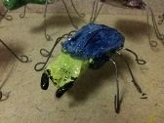 | Ceramic Bugs | Juliette Ripley-Dunkelberger |  | Juliette will bring her box of examples and teach you to make bugs from clay. You can take photos, ask questions and leave with several lesson plans. |  | Activity 421
 | Printmaking | Leslie Stein Moon |  | Learn a fun and simple relief printing technique to teach your kids. They can create an original image and then experiment with printing it as a mono print. Leslie is a professional artist who makes fabulous, happy and fun prints sold in local galleries. https://lesliemoon.wordpress.com/about-my-process/ |  | Sockeye 322
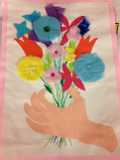 | Multi Media Picasso Flowers | Linda Mori |  | With Picasso as our inspiration, we will work with mixed media to create a personalized and layered piece, great for a Springtime lesson or Mother’s day. |  | Library
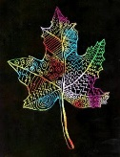 | Oil Pastel Scratch technique | Peggy Breautigam |  | You will learn this versatile technique for using oil pastels and creating sharp lined images. It is also called Sgraffito. http://peggybraeutigam.com/ |  | Library
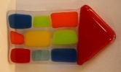 | Glass Fusing | Shelly Voldstedt |  | How to work with glass and kids. Learn the basics of glass fusing with our local glass expert. |  | Chinook 427
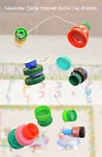 | Wire Mobile and Sculpture | Tanya Hansen |  | Take your small found objects and turn them into a Calder inspired, treasured art piece that moves. |  | Coho 422
2:30 – 3:30
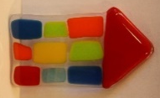 | Glass Fusing | Shelly Voldstedt |  | How to work with glass and kids. Learn the basics of glass fusing with our local glass expert. |  | Chinook 427
 | Printmaking | Leslie Stein Moon |  | Learn a fun and simple relief printing technique to teach your kids. They can create an original image and then experiment with printing it as a mono print. Leslie is a professional artist who makes fabulous, happy and fun prints sold in local galleries. https://lesliemoon.wordpress.com/about-my-process/ |  | Sockeye 322
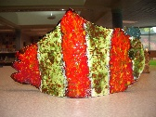 | Clay Projects with slabs | Juliette Ripley-Dunkelberger |  | Juliette will bring her box of examples and work through a slab lesson. You can take photos, ask questions and leave with several lesson plans. |  | Activity 421
 | Wire Mobile and Sculpture | Tanya Hansen |  | Take your small found objects and turn them into a Calder inspired, treasured art piece that moves. |  | Coho 422
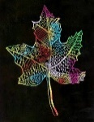 | Oil Pastel Scratch technique | Peggy Breautigam |  | You will learn this versatile technique for using oil pastels and creating sharp lined images. It is also called Sgraffito. http://peggybraeutigam.com/ |  | Library
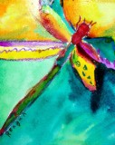 | Oil pastels & liquid water colors | Betsy Matias |  | Learn to create bright, beautiful, vibrant works of art in this mixed-media style that can be applied to almost any theme or idea. The art elements of LINE, SHAPE, COLOR & SPACE will be our guide. Learn how to present a directed lesson full of learning, yet open-ended enough to allow for lots of individual creativity and artistic style. http://www.henryandmei.com/about/ |  | Volunteer 210

