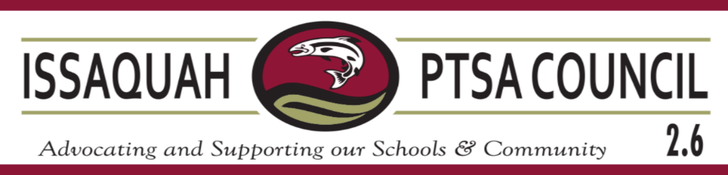
General Membership Meeting Agenda
Thursday, May 16th, 2024 - Hybrid Option

Welcome (Open Meeting) 10 Erin Eaton

Election of the 2024-2025 Executive Committee Erin Eaton

Approval of the 2024-2025 Budget Erin Eaton

Appointment of the 2024-2025 Bank Signers Erin Eaton

Adjourn 10:15

Upcoming Events

5/17-19 – WSPTA Annual Convention Convention - WSPTA (wastatepta.org)


2023-24 Issaquah PTSA Council – Contact Information
Executive Committee:
Erin Eaton
president@issaquahptsa.org
Lauren Bartholomew
secretary@issaquahptsa.org
Nikki Mason
treasurer@issaquahptsa.org
Karissa Mobilia
vp-secondaryschools@issaquahptsa.org
Middle Schools: Beaver Lake, Cougar Mountain, Issaquah, Maywood, Pacific Cascade, Pine Lake
High Schools: Gibson Ek, Issaquah High, Liberty, Skyline
Kristi Hammond
vp-el-south@issaquahptsa.org
South: Apollo, Briarwood, Clark, Cougar Ridge, Issaquah Valley, Maple Hills, Newcastle, Sunset
Tracie Jones
vp-el-north@issaquahptsa.org
North: Cascade Ridge, Cedar Trails, Challenger, Creekside, Discovery, Endeavour, Grand Ridge, Sunny Hills
Standing Committees: |  | Ad Hoc Committees:
Lauren Bartholomew & Shannon Mayo  advocacy@issaquahptsa.org  Laurelle Graves & Pauline Tamblyn  artdocent@issaquahptsa.org  Lovenia Hardin  dei@issaquahptsa.org  Laura Ni & Melissa Valdez  face@issaquahptsa.org  Simran Puri  membership@issaquahptsa.org  Angela Dahrea  outreach@issaquahptsa.org  Hannah Bowen  parentwiser@issaquahptsa.org  Angie Warren & Simran Puri  reflectionsisd@issaquahptsa.org  Betsy Grant  special-education@issaquahptsa.org  Laura Ni  webmaster@issaquahptsa.org |  | Laurelle Graves  InfluenceTheChoice@issaquahptsa.org  Laila Collins  isf-rep@issaquahptsa.org  VIS – please consider a donation  vis-rep@issaquahptsa.org
Issaquah PTSA Council Notes:
- Issaquah PTSA Council serves all local PTAs and PTSAs in the Issaquah School District Council – IssaquahPTSA.org
- Facebook: Issaquah PTSA Council 2.6
- Washington State PTA Website: WAStatePTA.org
login: PTALeader password: Advocate
- National PTA: PTA.org
- Upcoming Trainings – WAStatePTA.org/Events

